**Lab – 37: How to create a policy in Intune?**

**Objective:** The objective of this lab is –

* To create a policy in Intune.

In this lab, we are going to create a compliance policy in Intune. Compliance policies not only help you to manage specialized device types, such as corporate-owned kiosks, but also personal devices, tablets, and user-less devices. You can create compliance policies for each platform separately. For this lab, we’ll stick to iOS.

**Prerequisite:** EMS Enterprise Mobility + Security E5.

**Steps:**

1. Sign in to your Azure Portal, by using the link - **https://portal.azure.com/**. Enter your credentials and click Sign In.

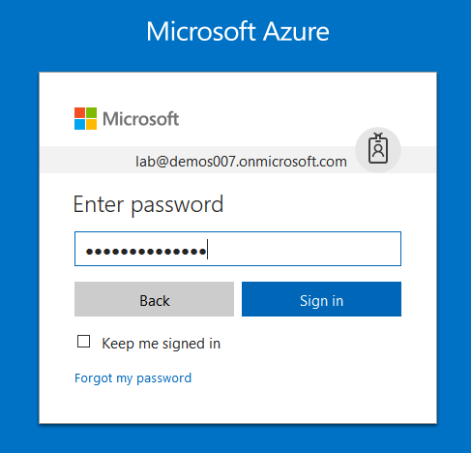

1. Microsoft Azure AD Dashboard will open.

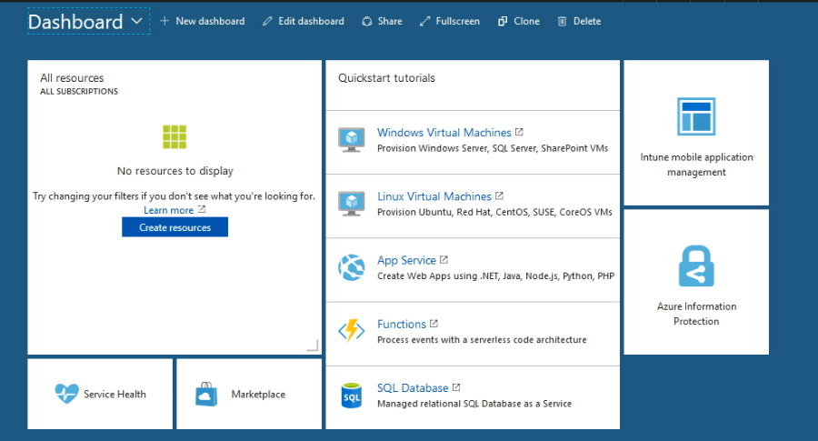

1. Open **Microsoft Intune** service from the left-hand side of the Azure portal.
2. Once you've opened the **Microsoft Intune** blade, select **Device Compliance**.

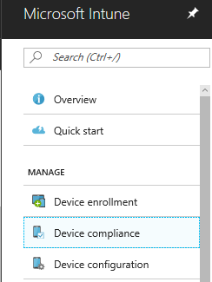

1. On the **Device compliance** blade, select **Policies**.
2. Select **+ Create Policy**.

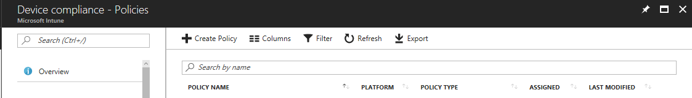

1. Then fill in the details, like **Name** and **Description**. Choose **iOS** as the Platform.

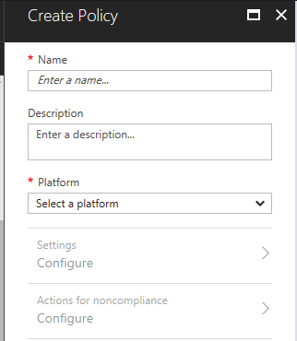

1. Then, select **Settings.** In this you can select a setting to configure settings like – Email, Device Health, Device Properties and System Security.

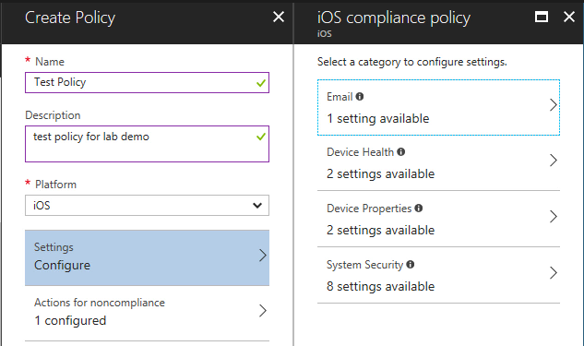

1. Select **System Security**, then toggle **Require a password to unlock mobile devices** to **Require**. You can also set other rules, such as **Minimum password length**, **Required password type**, and **Number of non-alphanumeric characters in password**, **Maximum minutes of inactivity before password is required**, **Password expiration in days** and **Number of previous passwords to prevent reuse**. When you’ve finished setting up your policy, select **OK**.

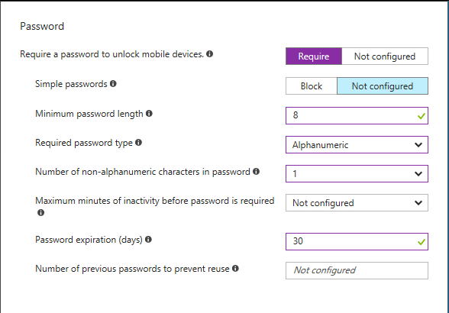

1. Then in iOS compliance policy select **OK**.
2. Return to the **Create policy** blade, then select **Create**.
3. Now you can see a policy is created and a notification will also pop-up.

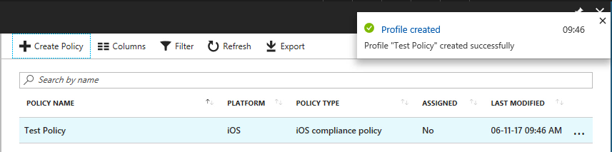

1. Once the policy is created, select **Assignments** to assign it to your **test group**.

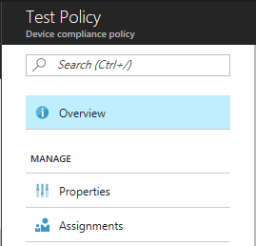

1. In the **assignments** blade select **Include** Tab. Then select groups to include.

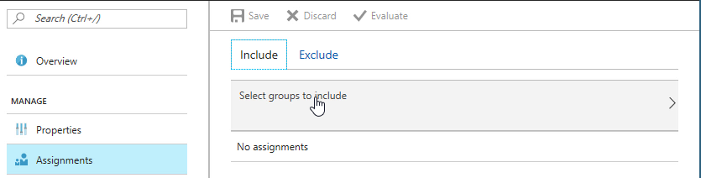

1. Select your test group – which should have your user in it. Click **Select**.

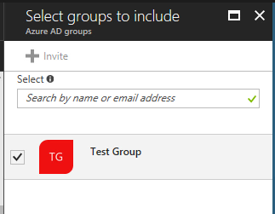

1. Now the test group in included for this policy. Then assign the policy to that group by clicking **Save**.

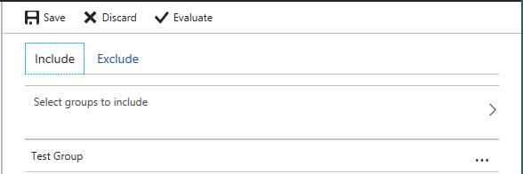

1. Assignments saved successfully notification will pop-up.

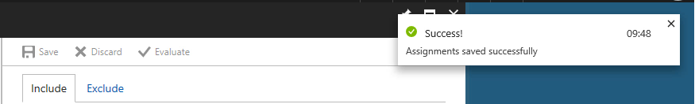

1. Then go to properties blade, to get the details of your created policy.

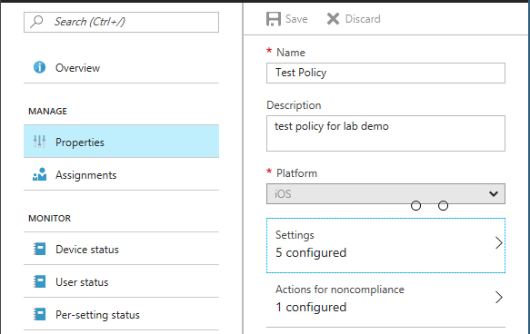

1. So, in this way you can create a compliance policy in Intune.